**WEEK 1 WORD FILE**

**WHAT IS MACHINE LEARNING**

Machine Learning (ML) is a branch of artificial intelligence where computers learn from data instead of being explicitly programmed. It involves training models to recognize patterns, make predictions, or perform tasks automatically based on experience. The more data they process, the better they get at solving problems—like recommending movies, predicting weather, or even detecting fraud in banking.

Machine Learning (ML) is like teaching computers to learn from experience, just like humans do! Instead of programming them to do specific tasks step by step, we feed them lots of data, and they figure out patterns and make decisions on their own.

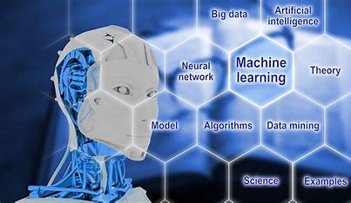

For example, imagine teaching a kid to recognize cats and dogs. Instead of telling them all the rules, you show them many pictures, and over time, they start identifying the animals themselves. ML works in a similar way, helping computers recognize speech, predict weather, recommend movies, and even drive cars.



**WHAT IS SUPERVISED LEARNING ALGORITHM**

Supervised machine learning is a fundamental approach for machine learning and artificial intelligence. It involves training a model using labeled data, where each input comes with a corresponding correct output. The process is like a teacher guiding a student—hence the term “supervised” learning. In this article, we’ll explore the key components of supervised learning, the different types of supervised machine learning algorithms used, and some practical examples of how it works.

**supervised learning** is a type of machine learning where a model is trained on labeled data—meaning each input is paired with the correct output. the model learns by comparing its predictions with the actual answers provided in the training data. Over time, it adjusts itself to minimize errors and improve accuracy. The goal of supervised learning is to make accurate predictions when given new, unseen data.

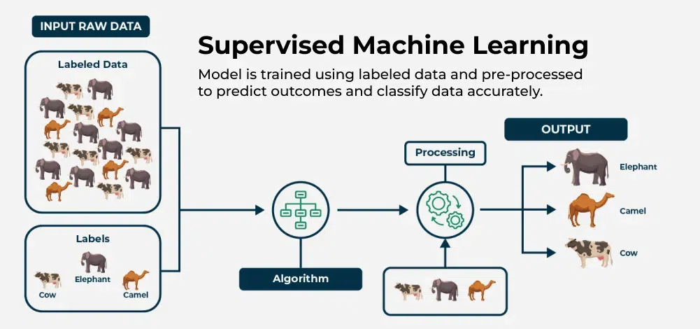

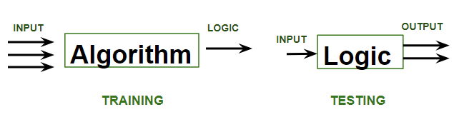

**WHAT IS REGRESSION AND CLASSIFICATION**

**REGRESSION:**

Regression in machine learning refers to a [**supervised learning**](https://www.geeksforgeeks.org/supervised-machine-learning/)technique where the goal is to predict a continuous numerical value based on one or more independent features. It finds relationships between variables so that predictions can be made. we have two types of variables present in regression:

* **Dependent Variable (Target)**: The variable we are trying to predict e.g house price.
* **Independent Variables (Features)**: The input variables that influence the prediction locality, number of rooms.

**CLASSIFICATION**

Classification teaches a machine to sort things into categories. It learns by looking at examples with labels (like emails marked “spam” or “not spam”). After learning, it can decide which category new items belong to, like identifying if a new email is spam or not.

